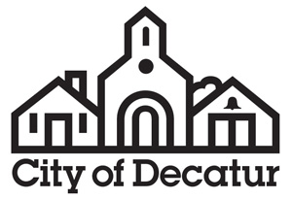

AGENDA

Public Facilities Authority

City Hall
Commission Meeting Room
Called Meeting
Monday, July 17, 2017
6:00pm

- Call to Order by Chair.

- Approval of Minutes.
Approval of the minutes of the meeting of June 5, 2017.

- Public Comment on Agenda Action Items.
The public is invited to comment on agenda action items.

- Agenda Action Items.

- Resolution Approving Loan Agreement between the Public Facilities Authority and Clean Water State Revolving Fund, Administered by Georgia Environmental Finance Authority.
- Resolution Approving Environmental Facilities Agreement by and between the Public Facilities Authority and City of Decatur.
- Resolution Approving Issuance of Bonds.
- Approval of Public Facilities Authority By-Laws.

- Adjournment.

Consistent with requirements of O.C.G.A. §50-14-1.(e)(1) the final agenda was posted on July 17, 2017.

