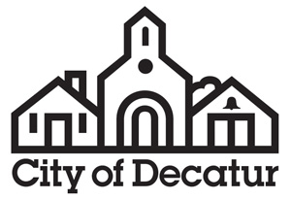

AGENDA

Public Facilities Authority

City Hall
Commission Meeting Room
Called Meeting
Monday, June 5, 2017
6:45pm

- Call to Order by Chair.

- Approval of Minutes.
Approval of the minutes of the meeting of May 10, 2017.

- Public Comment on Agenda Action Items.
The public is invited to comment on agenda action items.

- Agenda Action Items.

- Resolution Approving Issuance of Bonds, Form of Intergovernmental Agreement and Form of Assignment and Assumption Agreement.

- Adjournment.

Consistent with requirements of O.C.G.A. §50-14-1.(e)(1) the final agenda was posted on June 2, 2017.

