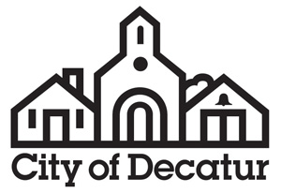

AGENDA

Public Facilities Authority

City Hall
Commission Meeting Room
Called Meeting
Wednesday, March 2, 2022
5:30pm

- Call to Order by Chair.

- Approval of Minutes.
Approval of the minutes of the executive session and called meeting of December 10, 2019.

- Public Comment on Agenda Action Items.
The public is invited to comment on agenda action items.

- Agenda Action Items.

- Election of Officers.

  - Election of Chairperson for 2022.
  - Election of Vice Chairperson for 2022.
  - Election of Secretary/Treasurer for 2022.

- Resolution R-22-PFA-XX Approving Issuance of Refunding Bonds, Authorizing and Approving Intergovernmental Agreement with the City of Decatur, Purchase and Sale Agreement with the City of Decatur, Offering Documents and Winning Bid for Refunding Bonds, and Other Purposes.

- Adjournment.

Consistent with requirements of O.C.G.A. §50-14-1.(e)(1) the final agenda was posted on February 25, 2022.

