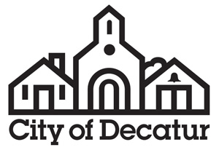

AGENDA

Public Facilities Authority

City Hall
Commission Meeting Room
Called Meeting
Tuesday, January 16, 2018
6:15pm

- Call to Order by Chair.

- Approval of Minutes.
Approval of the minutes of the meeting of July 17, 2017.

- Public Comment on Agenda Action Items.
The public is invited to comment on agenda action items.

- Agenda Action Items.

- Election of Officers.

  - Election of Chairperson for 2018.
  - Election of Vice Chairperson for 2018.
  - Election of Secretary/Treasurer for 2018.

- Adjournment.

Consistent with requirements of O.C.G.A. §50-14-1.(e)(1) the final agenda was posted on January 5, 2018.

