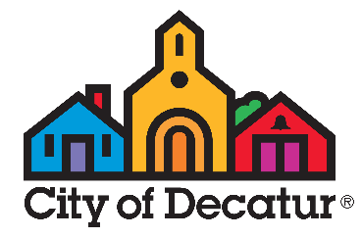
AFTERSCHOOL LOTTERY FAQ
City of Decatur Children and Youth Services (CYS)
K-5th Afterschool Programs
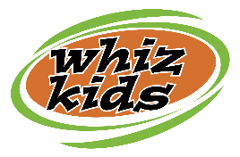
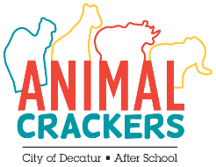

Q: When can I register my child for the afterschool lottery?
A: Starting at 10:00 am February 21, 2023 and continuing through 6:00 pm on April 21, 2023 children who will be in K-5th grades in the 2023-24 school year may be registered for the Afterschool lottery for 2023-24 programs. On April 28, 2023, Children and Youth Services (CYS) will run its lottery process to place registrants in the available afterschool spots for seven programs (Clairemont Animal Crackers, Glennwood Animal Crackers, Oakhurst Animal Crackers, Westchester Animal Crackers, Winnona Park Animal Crackers, Talley Street Whiz Kids (3rd-5th) and Fifth Avenue Whiz Kids (3rd-5th).
Q: Who is eligible to participate in the afterschool lottery?
A: The City of Decatur’s afterschool programs are available to all rising K-5th graders (children who will be in K-5th grades in Fall 2023) who are enrolled in City Schools of Decatur.
If your family is new to Decatur but you do not yet have a property deed or lease in the city, you will not be able to enter your child in the lottery. Once you have submitted proof of residency, you may register your child; however, you must be enrolled at one of the City Schools of Decatur.
The City of Decatur does not operate the pre-K afterschool program at College Heights Early Childhood Learning Center (ECLC). Please contact ECLC directly to inquire about the program there.
Q: Which program do I need?
A: Children may be registered for the lottery at their school site only. Families should register children for the eligible activity via Lottery Registration on CommunityPass. Children may not attend programs at a school they do not attend.
Q: How does the afterschool lottery work?
A: The lottery process is operated using a random number generator to sort and place lottery registrants in the available spots at each program. The Children and Youth Services staff team will fill all available spaces in the city's seven afterschool programs on April 28, 2023.
Following the lottery process, children that are placed in programs will receive an eligibility email from CommunityPass indicating they are eligible to register. The registration fee to hold a spot in the afterschool program is $35 per child. Those who are not placed in available program slots will be placed on the waitlist for the program in the order of their random numbers per the lottery process. Lottery registration can be confirmed by logging into CommunityPass, selecting My Account from the menu and then selecting My History. Families will be contacted to confirm enrollment no later than May 15, 2023.
Q: How do I register for the afterschool lottery?
A: Create a family account in CommunityPass (if you have not already done so) so that you’ll be ready to register for the lottery when it opens after Presidents Day. CommunityPass can be found at https://register.communitypass.net/cityofdecatur. Once you have a family account, login to CommunityPass, select the 2023-24 Afterschool Programs season and complete the two required forms: 2023-24 Afterschool Information and Release Form and 2023 Afterschool Health History Form. Then add your child to the appropriate afterschool lottery activity. The Lottery activities can be found by going to Click Here to Register > 2023-24 Afterschool Programs > choose program(s) child is eligible for and add to cart – complete checkout process to “Finish”.
Q: What is the cost of lottery registration?
A: Lottery registration costs $0. If your child is placed in the program via the lottery, you’ll be invited to register and pay your $35 registration fee at that time.
Q: I registered my child, now what?
A: The short answer is that you will simply need to wait until after April 28, 2023 for the results of the lottery process. The longer answer is that we strongly encourage you to double check your registration status by logging into CommunityPass and checking your registration history. Common lottery mistakes include:
- Failure to complete the transaction by exiting the session before completing Checkout – even though there is no cost for lottery registration if you do not complete the checkout process you will lose everything in your shopping cart and your child will not be entered in the lottery.
- Registration for the current school year rather than the future school year – be sure the activity you enrolled in specifies that it is a Lottery activity and that the school year matches next school year rather than the current year. Sometimes families add their child to the current school year waiting list rather than the lottery section for the upcoming school year.
- Failure to add all desired programs – Completing a form is NOT a registration. You must take the additional step to add your child to the Lottery activity. Once you have completed all the steps you will see all three items appear under the child’s name in your Family Account in CommunityPass.

Q: What are my chances?
A: The Animal Crackers (K-2nd) and Whiz Kids (3rd-5th) programs are in very high demand. Typically, some children will be placed in the program and others will be waitlisted. We always recommend you have a explore all of your potential afterschool options as our programs have limited capacities based on staffing and program space at each of our program sites.
Q: If we are waitlisted, will we get in before school starts?
A: There is always a chance that children on the waiting list may be invited to enroll before school begins; however, if your child is placed on the waiting list via the lottery spin, we strongly encourage you to investigate other options. A waitlist position is NOT a promise of afterschool care – regardless of how low your child’s waitlist number might be.
Q: I missed the lottery. What do I do?
A: Once lottery registration closes on April 21, the 2023-24 afterschool registration process will be closed temporarily in preparation for the lottery spin on April 28. Afterschool registration for 2023-24 will reopen on a first-come basis on May 3 at 10 am.
At that time, K-5th programs will likely be full with waiting lists from the lottery process so registration involves adding your child to the waiting list. If you are new to CYS and Active Living programs, you will need to complete the Afterschool Information and Release Form and Afterschool Health History Form in order to add your child to the waiting list for a full program. You will create your family account on CommunityPass as well as completing the two pre-requisite forms.

